**Loon Survey and Wildlife Observations**

*Survey Dates: Saturday, June 24 to July 1, 2017*

*Joyce Benham and Bob Carrière*

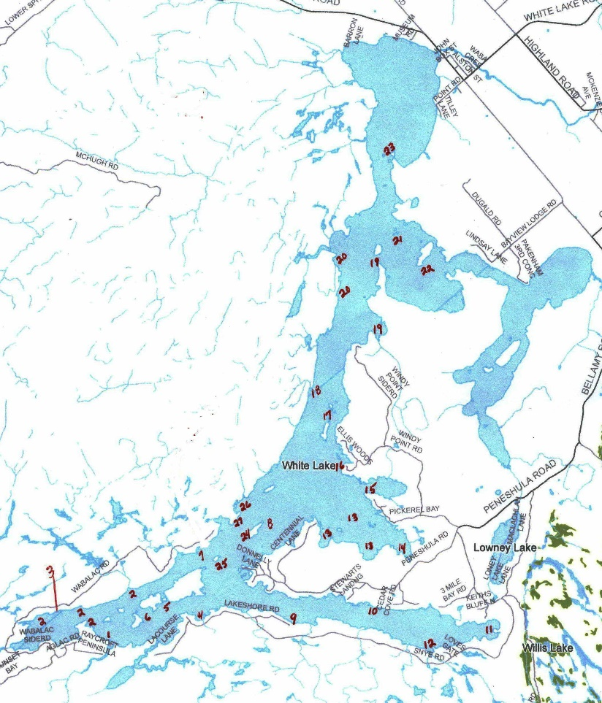This year was an especially wet year with nearly a metre of water falling on White Lake as rain. We were concerned that high water levels could result in nesting failures. This was not the case. All or most of the chicks seen this year were much larger than in previous years and all appeared active and in good health. There appeared to be plenty of food for all water fowl on the lake. Minnows and literally clouds of small fish were easily seen with the increased clarity of the water. For the second year, we have not encountered deer or other large mammals along the shore of the lake.

**Observations:**

**Site 1:** Broad Brook shallows always delivers a very co-operative adult couple with two chicks, very tolerant of our presence and very photogenic. This has become our favorite and most predictable area for us to visit. In the past, other couples were seen in the vicinity of the southern part of Hardwood I., but not this year. It is likely that at this location nesting sites may have been affected by high water levels. However, there appeared to be new occupants in the shallows/channel between parts of Harwood Island but we did not dare venturing deeper for fear of grounding our boat.

**Site 2:** The Northwest shore is always abundant with Blue Herons but some of the rocky outcrops south of Hardwood I. were water-covered which affected the usual traffic of sea gulls and blue herons.

**Site 4:** The rocks at this location were almost entirely water-covered and no loon activity was noticed.

**Site 9:** The south shore of Three Mile Bay continues to produce numerous loon couples with chicks, possibly 4 or 5 pairs, seeking refuge from pleasure boats in the many undeveloped bays. Yet, against all odds, we constantly see adults in the main channel dodging speed boats.

**Site 10:** This site was more flooded than usual and the ospreys from previous years have lost their nesting tree to the weather. Ospreys are definitely still around and seen flying/feeding over the bay, but nesting sites have probably been moved to more protected areas in the interior. Half way up the southeast side of Hardwood Island, the new osprey nest from last year was occupied by adults and two chicks.

**Site 11:** Once again this site was not occupied by loons. This was disappointing for us as there were always one or two couples present with chicks. Also, conditions were ideal for photography with the late afternoon sun and lack of boating activity.

**Site 12:** This site was active with 2 adults and 2 chicks of fair size.

**Sites 13/14:** Pickerel Bay has maintained its large osprey nest with two chicks, although the supporting rocky islands seemed much smaller with the higher water levels. Pairs of loon adults (no chicks) were located in the far reaches of the bay. The rocky alcoves on the south shore of Pickerel Bay were populated with 2 or possibly 3 pairs, some with chicks, but again the high water hiding known rocky areas and dead heads kept us from getting closer.

**Site 15:** Eggshape bay had a couple of adults with 2 chicks and this year we were able to navigate the bay without grounding the boat on sand bars. There were numerous sightings of Blue Herons on the grassy shoreline.

**Site 16:** The usual loon couple with 1 chick were seen navigating the rocky shallows between Stanley and Waba Islands. The eagle’s nest on Stanley Island was still active but the 2 chicks were already flying from branch to branch. The Southern rocky point of Stanley I., were herons are usually seen fishing, was almost totally submerged.

**Site 18:** The bay below and east of Deadman’s Island was active with the usual Osprey nest where two chicks were seen. A pair of adult loons with one chick was also observed. There were some bald eagles flying in the far back reaches of the same bay. The eagle’s nest was once located on the water’s edge below the Bay, but now could have been moved to a quieter area inland.

**Site 19:** Nesting areas on sand were totally flooded with no loons present.

**Sites 20, 21, 22:** Despite heavy boat traffic, two adults with two chicks were seen north of Richardson’s Island. Another couple with two chicks were also seen behind Russell’s Island. Reid’s Island hosted 2 sets of adults with one fairly large chick each.

Across from the main channel at Site 20, near the opening to Fish Creek, there were at least one nesting pair with two chicks and numerous other fishing bachelors seen on various occasions. We boated past the almost submerged rocks at Ryan’s point and the familiar osprey nest which was gone last year has not been rebuilt

**Site 24:** Birch Island had an active Osprey nest as in previous years but the chicks had already fledged when we arrived.

**Site 25:** This co-operative fishing area was still active late in the evening attracting 5 to 6 adult loons.

**Site 26:** This site had two pairs of adults with one chick each.

**Site 27:** Unlike previous years, no loons were observed at this site and adjoining marsh.

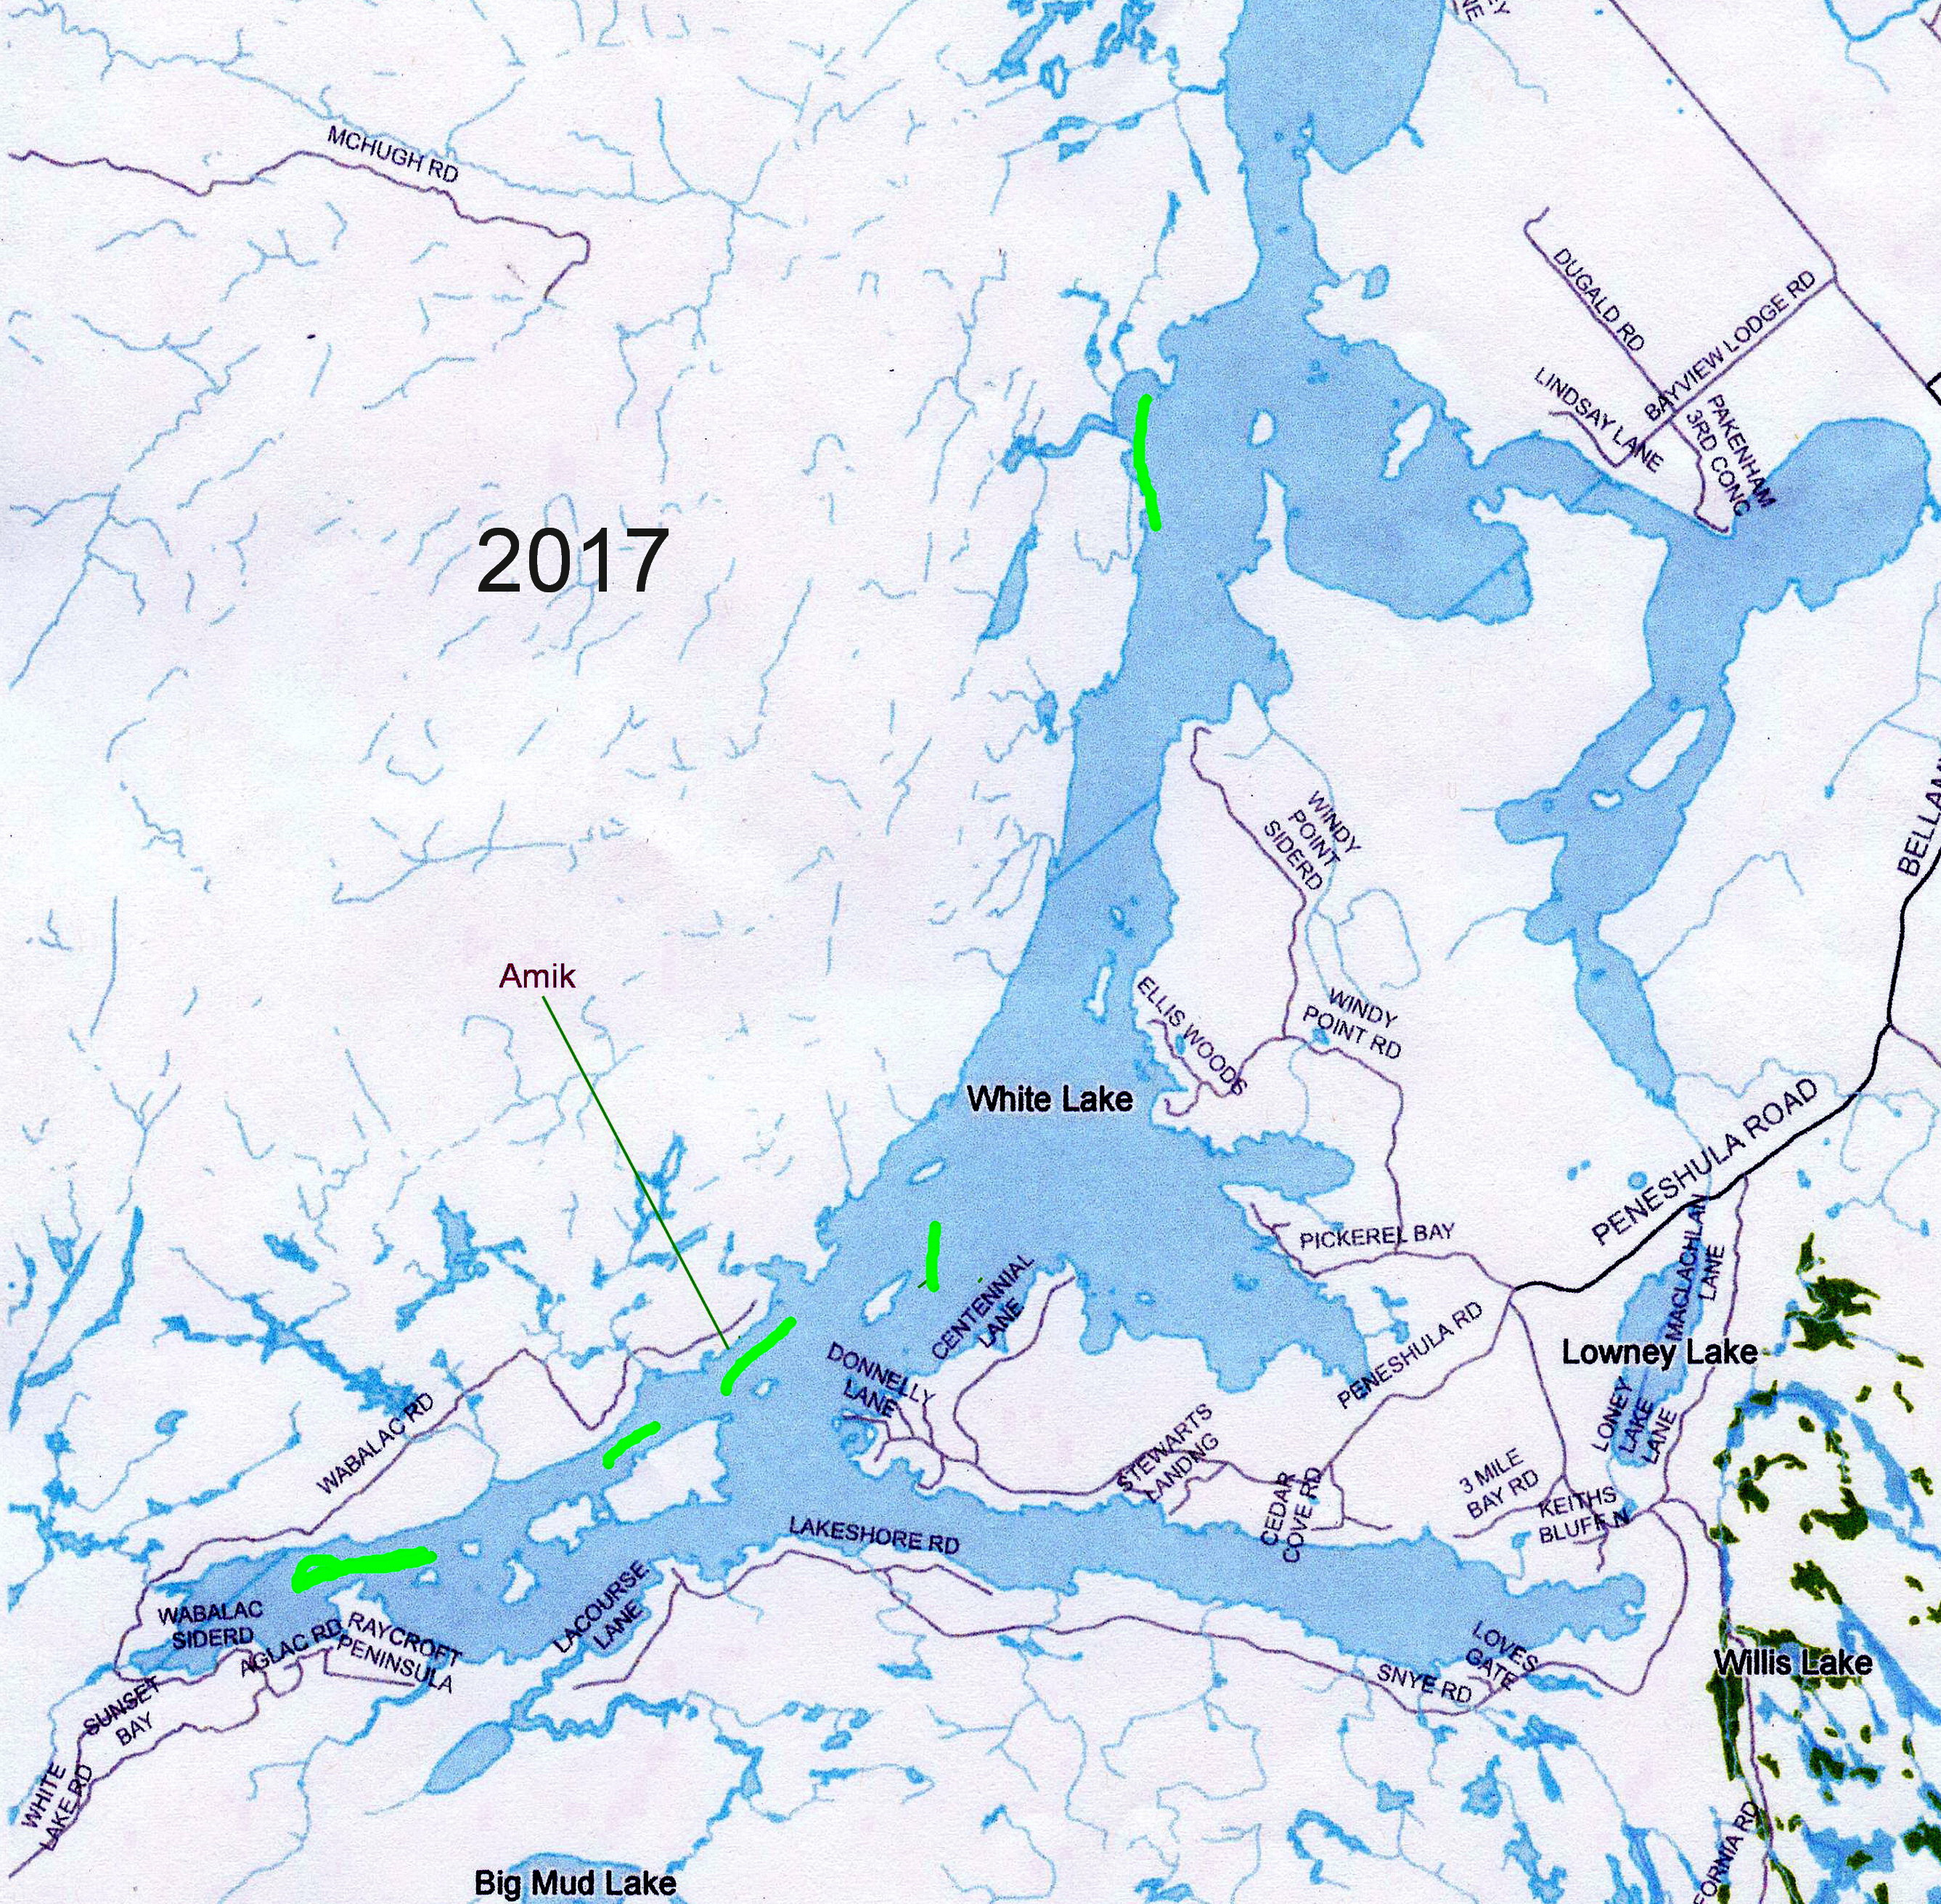**Cooperative Fishing:**

The map to the right shows areas along the shoreline where loons have been observed doing cooperative fishing.

The green highlighted areas are locations where we have seen adult loons gather late in the evening for what appears to be a co-operative line fishing and feeding.

The loons appear to swim in a line formation until one sees prey after which they collectively dive, resurface and repeat the same process. At other times one or two loons will literally fly on the surface of the water beating their wings loudly in the water for 100 metres or so. They then swim around and resume their fishing.  We always considered these adults as bachelors without mates but witnessed otherwise this summer.  The areas of collective fishing are all located in what we would call deep channels, while at the same locations, we have never seen local nesting couples.

**SURVEY RESULTS:**

During the 2017 observation period, we counted 45 adult loons on White Lake, producing 19 mating pairs with 21 offspring.